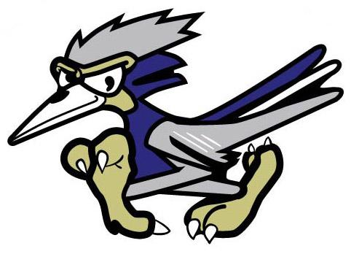



Riverside Meadows Dance Permission Slip

DANCE POLICY AND PERMISSION SLIP

The following is a list of requirements and expectations for attending dances at Riverside Meadows. Attendance at school dances requires that both the student and the student’s parent or guardian sign the dance permission slip.

1. Before the Dance
   1. Students must present permission slips at the time of ticket purchase
   2. Students will need a ticket to enter the dance.
   3. Students whose name appears on the “No Activities List” will not be allowed to purchase a dance ticket, their money will be refunded, and they will not be allowed to attend.
   4. Students must have a 2.0 GPA and NO F’s
2. Requirements and Expectations During and After the Dance
   1. Respectful, polite behavior is expected.
   2. No inappropriate dancing- this may result in a student being sent home early.
   3. Dances are only for Riverside Meadows students ONLY
   4. Students must enter the dance within 30 min. of the dance start time and are to remain at the dance until the end unless they are picked up early by a parent or guardian
   5. Students are encouraged to leave valuables at home
   6. Parents are welcome to accompany their children to all dances. Parents may volunteer as chaperones, snack bar help, ticket table, and general supervision.
   7. STUDENTS WHO VIOLATE ANY OF THE DANCE OR DISCIPLINE RULES MAY BE EXCLUDED FROM FUTURE DANCES AND/OR PLACED ON THE “NO ACTIVITIES LIST. "

NO BACKPACKS OR LARGE BAGS WILL BE ALLOWED INTO THE DANCE.

STUDENT NAME: __________________________________________ GRADE:______________

PARENT/GUARDIAN NAME: _____________________ CONTACT #:________________________

PARENT/GUARDIAN SIGNATURE:___________________________________________________